# WORKSHEET-2.2

# Student’s Name: shubham bawankar

# UID: 20BCS7409

# SECTION/GROUP: 20CSE10/B

## Screenshot 1-

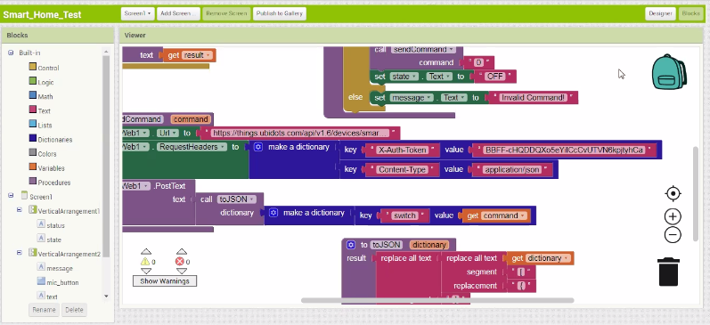

## Screenshot 2-

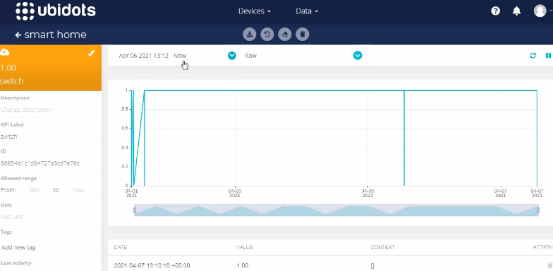

## Screenshot 3-

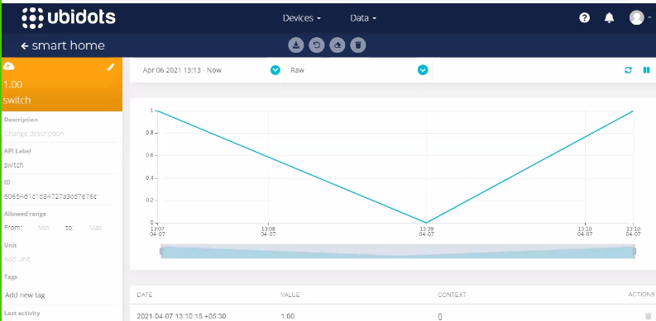

## Screenshot 4-



 